PRESS RELEASE

Products and Solutions For Single Pair Ethernet In Industrial Environments
Telegärtner, Phoenix Contact, Weidmüller, Reichle & De-Massari and Fluke Networks are developing mutually compatible components for Single Pair Ethernet

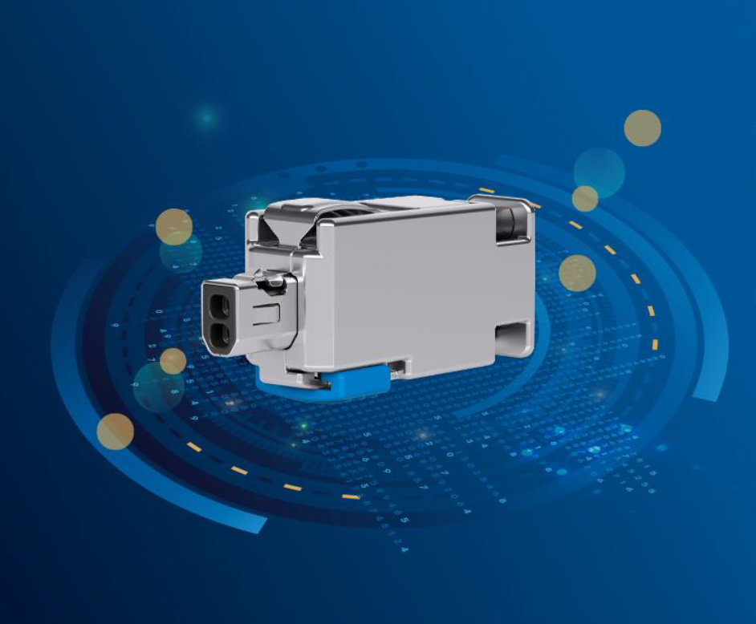
Diagram 1: SPE field-wireable IP20 connector

Steinenbronn, 25.11.2019. The companies Telegärtner, Phoenix Contact, Weidmüller, Reichle & De-Massari and Fluke Networks are presenting products and solutions for Single Pair Ethernet (SPE) in industrial environments at the SPS - Smart Production Solutions trade fair. These companies are developing and supporting the mating faces collectively added to the IEC 63171-2 (office environment) and IEC 63171-5 (industrial environment) standards. These standards define IP20 and IP65/67 mating faces for single- and four-pair data transmission in SPE applications. The companies in this partnership are pooling their technological expertise in order to ensure a standardised infrastructure for devices, connectors, cables and measurement technology. As they put it: “There’s no alternative to Single Pair Ethernet. It’s the key technology of the future and will enable end-to-end Ethernet-based communication in an unprecedented variety of application fields." The purpose of SPE is not to define new higher transmission speeds or distances, rather, it is to form the framework for standardising reduced amounts of cabling for applications. This reduced cabling brings completely new areas of application into focus.

Data cabling with just one pair of wires enables transmission distances of up to 1000 metres at transmission rates ranging from 10 Mbps to 1 Gbps. This means that SPE is particularly well suited for infrastructure applications in machine building and systems manufacturing, process engineering, and also in building infrastructure. The main advantage is that SPE is environment-independent. Field devices, sensors, and actuators can be easily incorporated into the existing company-level Ethernet environment. There is no need for additional gateways or interfaces. SPE is allowing Ethernet to penetrate down to field level, thus making it more consistent, more efficient and more cost-effective than existing fieldbus systems.

Development of the Single Pair Ethernet began in the automotive industry, where the trend towards developing smaller and better performing devices is clear to see. Future-oriented technologies such as autonomous vehicles require a connection technology that enables the high-speed transmission of data with a very small structural footprint. Other industries can also benefit from this approach. “Single Pair Ethernet means a reduction in the amount of work for systems manufacturers. Compared to four-pair Ethernet, installation is easier and enables a noticeable reduction in space and weight,” explains Jörg Scheer, Director of the Device & Field Connectivity Division at Weidmüller. Simon Seereiner, Director of Product Management IE and SAI at Weidmüller, adds: “In new installations, users save on procurement costs and can design the necessary cable runs to be much more compact. The standardised mating faces also enable the efficient cabling of many communication devices that share a common line and interface. This means that users can continue to use the existing cabling and connect up to four devices, instead of just one.”

Thanks to the standardised interfaces, single- and four-pair cabling concepts can be combined with each other just as IP20 and IP6x solutions can. The two-wire technology also enables the application-specific supply of end devices with outputs of up to 60 Watts via the same pair of wires (Power over Data Line – PoDL). “Our collaboration in this standardisation will create security,” says Torsten Janwlecke, President Business Area Device Connectors at Phoenix Contact. “Throughout the world, users will be able to construct efficient network and cabling structures, from the sensors, through the control and company level, right through to the Cloud, all based on standardised interfaces.” Scheer adds: “Thanks to digitalisation, intelligent networking is increasing in every aspect of life. Consistent data transmission is also becoming ever more relevant in the industrial environment. Therefore, Ethernet cabling is already replacing many traditional fieldbus systems today.”
SPE significantly reduces the total cost of the network infrastructure. At the same time it creates a standardised, coordinated, open network for complete consistency within the network levels.
“The smaller footprint frees up space for more ports, especially at the nodes. This in turn achieves more efficient use of the infrastructure," explains Marcel Leonhard, Director of DataVoice at Telegärtner.
“Moreover, SPE will create new potential in various market segments such as factory and process automation, but also in transport and logistics due to the integration of new device technologies.”

“Certification of the installed Ethernet cabling is the most effective way to ensure correct operation. This is independent of the number of conductor pairs in the cable," says Mark Mullins, Global Communications Manager and co-founder of Fluke Networks. “In this way, customers can be sure that their investment in high-quality cabling and components is worthwhile. We have worked with over 30 standardisation committees to define the future of cabling since the company was founded. Our goal is to define effective standards that also allow the development of tools which customers can use to certify this exciting new technology and fix faults, if necessary.”

About Telegärtner
Telegärtner, founded in 1945, is a globally operating end-to-end provider for professional solutions in connection and transmission technology, and is one of the largest manufacturers in this field. Over the decades, the family company has focused on sophisticated applications of building, IT and network technology. For more than two decades, Telegärtner has been providing extremely robust connection technology for industrial network applications with high bandwidth requirements.
Maximum customer orientation and sustained innovative power is the basis on which the globally acting Telegärtner Group develops, produces and sells professional tailor-made solutions. www.telegaertner.com

About Phoenix Contact
Phoenix Contact is a global market leader for components, systems and solutions in the field of electrical engineering, electronics and automation. The family company currently employs about 17,400 people worldwide and achieved a turnover of 2.38 billion euros in 2018. The headquarters is in Blomberg, Westphalia. The Phoenix Contact Group comprises fourteen Germany-based companies and more than 55 independent sales subsidiaries around the world. Its international presence is further strengthened by more than 40 commercial agencies in Europe and overseas. www.phoenixcontact.com

About Weidmüller
As experienced experts, we support our customers and partners around the world with products, solutions and services in the industrial environment of power, signal and data. We are at home in their industries and markets and know the technological challenges of tomorrow. We are therefore continuously developing innovative, sustainable and useful solutions for their individual needs. Together we set standards in Industrial Connectivity. The Weidmuller Group has manufacturing plants, sales companies and representatives in more than 80 countries. In its fiscal year 2017 Weidmüller reached a turnover of 740 million euros with approximately 4,700 employees. www.weidmueller.de

About Fluke Networks
Fluke Networks is the worldwide leader in certification, troubleshooting and installation tools for professionals who install and maintain critical network cabling infrastructure. From installing state-of-the-art data centres to restoring services in the most challenging environments, the combination of legendary reliability and unmatched performance ensures jobs are done efficiently. Further information is available at www.flukenetworks.com

Contact: Telegärtner Karl Gärtner GmbH
Lerchenstraße 35
D-71144 Steinenbronn
Tel. (Head Office): +49 7157/125-0
Website: https://www.telegaertner.com

